Full Stack Development with MERN
Project Documentation
1. Introduction
Project Title
ShopEZ – E-Commerce Web Application

2. Project Overview
Purpose
ShopEZ is a full-stack e-commerce web application developed using the MERN stack. The platform allows users to register, log in, browse products, add items to cart, enter delivery details, make payments, and track orders.
Features
- User Registration
- User Login Authentication
- Product Browsing
- Category Filtering
- Product Search
- Add to Cart
- Delivery Address Collection
- Payment Selection
- Order Placement
- My Orders Section
- Profile Section
- Responsive User Interface

3. Architecture
Frontend (React)
Frontend is developed using React.js.
Components:
- Navbar
- Categories
- Login
- Register
- Cart
- Address
- Payment
- Orders
- Profile
- Footer
Responsibilities:
- UI Rendering
- State Management
- API Communication
- Navigation

Backend (Node.js + Express.js)
Backend developed using:
- Node.js
- Express.js
Responsibilities:
- Authentication APIs
- Product APIs
- Cart APIs
- Order APIs
- Database Connection
Folders:
- routes
- controllers
- models
- middleware

Database (MongoDB)
MongoDB stores:
Users
- name
- email
- password
Products
- name
- price
- category
Cart
- user
- product
- quantity
Orders
- user
- products
- total

4. Setup Instructions
Prerequisites
Install:
- Node.js
- MongoDB
- VS Code
- Git

Installation
Clone:
git clone
Frontend:
cd client
npm install
npm run dev
Backend:
cd server
npm install
npm run dev
Environment Variables:
Create .env
PORT=8000
MONGO_URI=your_database_url
JWT_SECRET=your_secret_key

ShopEZ/
│
├── client/
│ ├── public/
│ │ └── vite.svg
│
│ ├── src/
│ │
│ │ ├── components/
│ │ │
│ │ │ ├── Navbar.jsx
│ │ │ ├── Categories.jsx
│ │ │ ├── Register.jsx
│ │ │ ├── Login.jsx
│ │ │ ├── Cart.jsx
│ │ │ ├── Address.jsx
│ │ │ ├── Payment.jsx
│ │ │ ├── Success.jsx
│ │ │ ├── Orders.jsx
│ │ │ ├── Profile.jsx
│ │ │ ├── Footer.jsx
│ │ │
│ │ ├── assets/
│ │ │ ├── logo.png
│ │ │ ├── banner.jpg
│ │ │
│ │ ├── App.jsx
│ │ ├── main.jsx
│ │ ├── App.css
│ │ └── index.css
│
│ ├── package.json
│ ├── vite.config.js
│ └── node_modules/
│
│
├── server/
│
│ ├── controllers/
│ │
│ │ ├── authController.js
│ │ ├── productController.js
│ │ ├── cartController.js
│ │ └── orderController.js
│
│ ├── routes/
│ │
│ │ ├── authRoutes.js
│ │ ├── productRoutes.js
│ │ ├── cartRoutes.js
│ │ └── orderRoutes.js
│
│ ├── models/
│ │
│ │ ├── User.js
│ │ ├── Product.js
│ │ ├── Cart.js
│ │ └── Order.js
│
│ ├── middleware/
│ │
│ │ └── authMiddleware.js
│
│ ├── config/
│ │
│ │ └── db.js
│
│ ├── .env
│
│ ├── index.js
│
│ ├── package.json
│
│ └── node_modules/
│
│
├── README.md
├── .gitignore
└── package-lock.json

6. Running Application
Frontend:
cd client
npm run dev
Backend:
cd server
npm run dev
Frontend URL:
http://localhost:5173
Backend URL:
http://localhost:8000

7. API Documentation
Register
POST
/api/auth/register
Request:
{
"name":"Harsha",
"email":"abc@gmail.com",
"password":"123456"
}
Response:
{
"message":"Registered"
}

Login
POST
/api/auth/login
Response:
{
"token":"jwt_token"
}

Products
GET
/api/products

Cart
POST
/api/cart
GET
/api/cart
DELETE
/api/cart/

Orders
POST
/api/orders
GET
/api/orders

8. Authentication
Authentication handled using:
- JWT Token
- Local Storage
Flow:
Register
↓
Login
↓
Token Generated
↓
Protected Pages
↓
Logout

9. User Interface
Pages:
- Home
- Dashboard
- Login
- Register
- Cart
- Address
- Payment
- Orders
- Profile
10. Testing
Testing Method:
Manual Testing
Validated:
- Registration
- Login
- Product Search
- Cart
- Checkout
- Orders
11. Screenshots / Demo
DASHBOARD:-
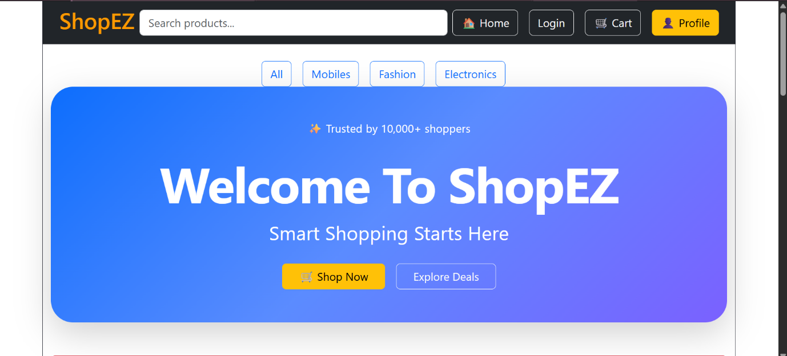
LOGIN PAGE:-
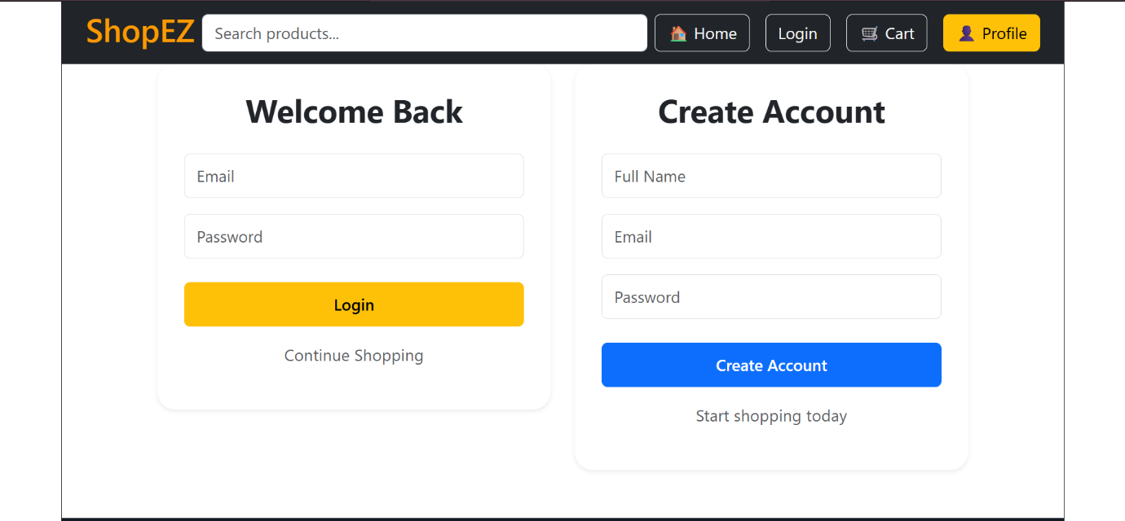

PRODUCTS PAGE:-
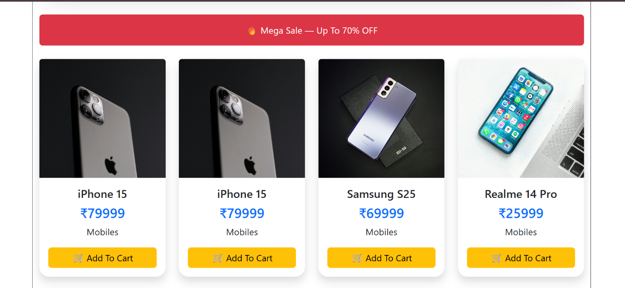
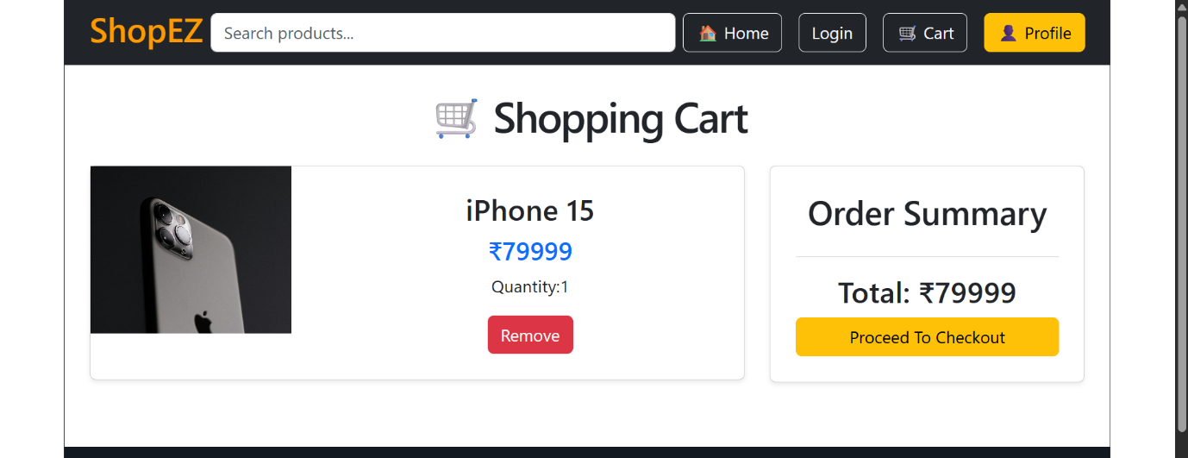
PROFILE PAGE:-
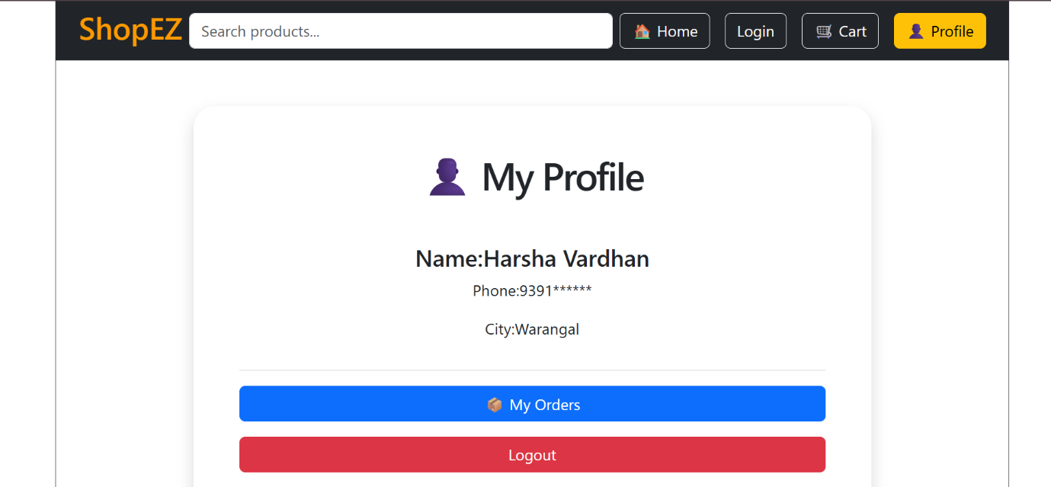
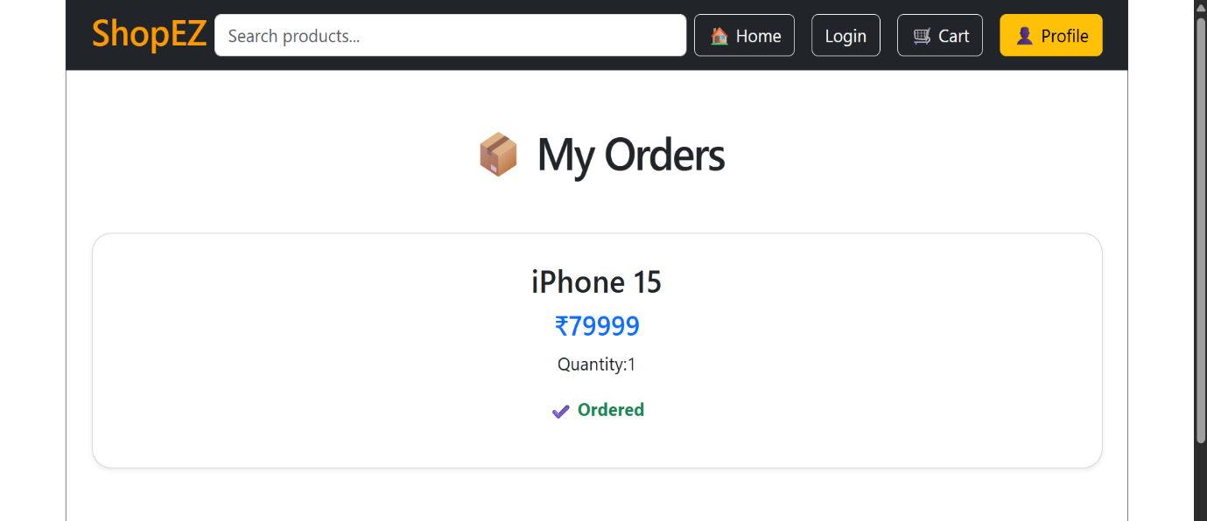
12. Known Issues
- Static Product Images
- Basic Cart Persistence
- Limited Payment Integration
13. Future Enhancements
- Razorpay Integration
- Wishlist
- Order Tracking
- Notifications
- Product Reviews
- Email Confirmation
- Inventory Management

